Edward C. Reed High School – Performing Arts
1350 Baring Blvd, Sparks, NV 89434 – 775 353 5700
Raider Band – Jazz Ensembles – Concert Bands – Indoor Programs www.raiderbands.com

Hello, I’m Ron Eichstedt the Band Director at Reed High School. I want to formally invite YOU to be a part of our growing music department where we offer a large selection of performance opportunities for Instrumental Music. Students are also able to participate in ROTC, Sports and AP/Honors course while performing in our ensembles.

If you do not have music selected as a course for next year, I am personally inviting you to join. For your first year I would highly recommend Marching Band as this is an ensemble that spends the most time together working hard and having fun.
Recently the Marching Band performed in the 2020 London New Year’s Day Parade in front of a half million spectators live and 5 million on TV around the world. Don’t worry!, Our next trip is scheduled for Rome in two years. Through experiences like these the bonds and friendships that are created will last a lifetime. Our hard work and time culminated this past Fall with the Marching Band achieving 1st Place in the AA Band Category at the 2021 Northern Nevada Championships and we want you to be a part of our 2022 success.
*Students that participate in Marching Band receive a PE Waiver for each semester.*

Next year, we will be presenting “BLACK WIDOW” which is designed to be a dark and mysterious pirate show. Our last AA Northern Nevada Champion show “How to Become a Junior Ranger” was a smash hit and the kids worked hard coming out of a hybrid school year. This next year we are looking to challenge the students as we prepare for our opportunity to march in the 2024 Rome New Years Day Parade. (Parents and Family welcome to attend)

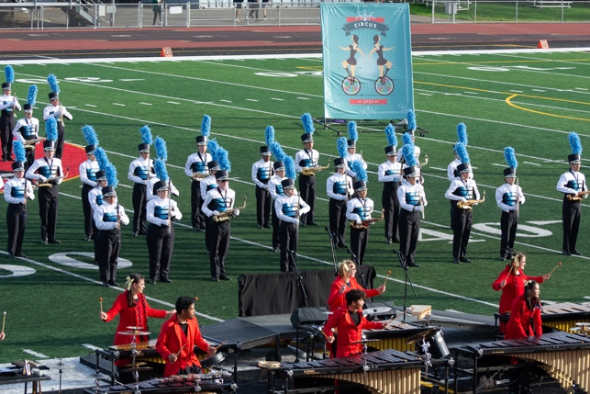
We also offer more great performance opportunities such as; Concert Band (recommended for incoming Freshman and students starting new instruments), Symphonic Band (Sophomore-Seniors or students taking lessons as Freshman), Wind Ensemble (Approval by Director, Audition), Jazz Ensemble (I/II, concurrent enrollment of Marching Band), Percussion (Beginner), Marching Band (Fall Only, T/Th 3-6:30 +Weekends and Football Games), Indoor Percussion/Guard/Winds (Spring, Schedules TBA), Basketball Pep Band (Spring, 6 Games + Play Offs).

Keeping your student involved in Music Education has a large array of benefits, the following are from NAFME (the National Association for Music Education):

1. Musical training helps develop language and reasoning: Students who have early musical training will develop the areas of the brain related to language and reasoning. The left side of the brain is better developed with music, and songs can help imprint information on young minds.
2. A mastery of memorization: Even when performing with sheet music, student musicians are constantly using their memory to perform. The skill of memorization can serve students well in education and beyond.
3. Students learn to improve their work: Learning music promotes craftsmanship, and students learn to want to create good work instead of mediocre work. This desire can be applied to all subjects of study.
4. Increased coordination: Students who practice with musical instruments can improve their hand-eye coordination. Just like playing sports, children can develop motor skills when playing music.
5. A sense of achievement: Learning to play pieces of music on a new instrument can be a challenging, but achievable goal. Students who master even the smallest goal in music will be able to feel proud of their achievement.
6. Kids stay engaged in school: An enjoyable subject like music can keep kids interested and engaged in school. Student musicians are likely to stay in school to achieve in other subjects.
7. Success in society: Music is the fabric of our society, and music can shape abilities and character. Students in band or orchestra are less likely to abuse substances over their lifetime. Musical education can greatly contribute to children’s intellectual development as well.
8. Emotional development: Students of music can be more emotionally developed, with empathy towards other cultures They also tend to have higher self esteem and are better at coping with anxiety.
9. Students learn pattern recognition: Children can develop their math and pattern-recognition skills with the help of musical education. Playing music offers repetition in a fun format.
10. Better SAT scores: Students who have experience with music performance or appreciation score higher on the SAT. One report indicates 63 points higher on verbal and 44 points higher on math for students in music appreciation courses.
11. Fine-tuned auditory skills: Musicians can better detect meaningful, information-bearing elements in sounds, like the emotional meaning in a baby’s cry. Students who practice music can have better auditory attention, and pick out predictable patterns from surrounding noise.
12. Music builds imagination and intellectual curiosity: Introducing music in the early childhood years can help foster a positive attitude toward learning and curiosity. Artistic education develops the whole brain and develops a child’s imagination.
13. Music can be relaxing: Students can fight stress by learning to play music. Soothing music is especially helpful in helping kids relax.
14. Musical instruments can teach discipline: Kids who learn to play an instrument can learn a valuable lesson in discipline. They will have to set time aside to practice and rise to the challenge of learning with discipline to master playing their instrument.
15. Preparation for the creative economy: Investing in creative education can prepare students for the 21st century workforce. The new economy has created more artistic careers, and these jobs may grow faster than others in the future.
16. Development in creative thinking: Kids who study the arts can learn to think creatively. This kind of education can help them solve problems by thinking outside the box and realizing that there may be more than one right answer.
17. Music can develop spatial intelligence: Students who study music can improve the development of spatial intelligence, which allows them to perceive the world accurately and form mental pictures. Spatial intelligence is helpful for advanced mathematics and more.
18. Kids can learn teamwork: Many musical education programs require teamwork as part of a band or orchestra. In these groups, students will learn how to work together and build camaraderie.
19. Responsible risk-taking: Performing a musical piece can bring fear and anxiety. Doing so teaches kids how to take risks and deal with fear, which will help them become successful and reach their potential.
20. Better self-confidence: With encouragement from teachers and parents, students playing a musical instrument can build pride and confidence. Musical education is also likely to develop better communication for students.

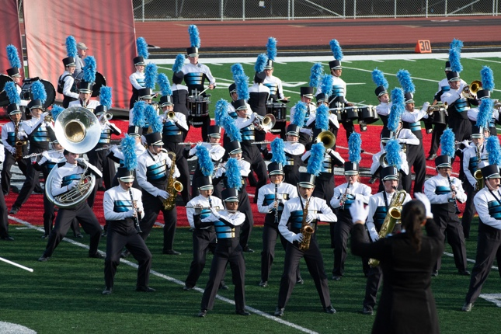
Important Dates
“Band Camp”
This is an important time where all the students get together before the school year begins and the group gains the skills necessary for us to be successful throughout the year. Please know that we are sympathetic to families that are traveling and missing band camp doesn’t mean a student CAN’T be in Marching Band. Actually, they CAN be in Marching Band but it may change the performance role they may hold for this season.

Band Camp (Band, Percussion and Guard)
Monday August 1-5, 11am-8pm
with a Parent Performance on Saturday August 5th @ 8pm

A detailed schedule will be released at Band Camp with all the dates and times for competitions, Saturday rehearsals and football games. Please be mindful that all performances and Saturday rehearsals are mandatory and it negatively hurts the group when we are missing students. Planning ahead guarantees a positive and productive experience for all.

If you have any questions or concerns please do not hesitate to reach out. I can be contacted at: rfeichstedt@washoeschools.net

More information can be found on the band website @ www.raiderbands.com

Thank you for reading this letter and I look forward to having you in the band.

Musically,

Ron Eichstedt
Director of Bands
Edward C. Reed High School
Sparks, NV
www.raiderbands.com
rfeichstedt@washoeschools.net

